CA-3
CAP276: Data Communication and Networking – Laboratory
Note:
- Odd roll number students of to perform Set A and Even roll number to perform Set B
- Put the resultant Packet tracer file in my private lpulive account.
Dr. Avinash Bhagat: 11002
Given the network scenario
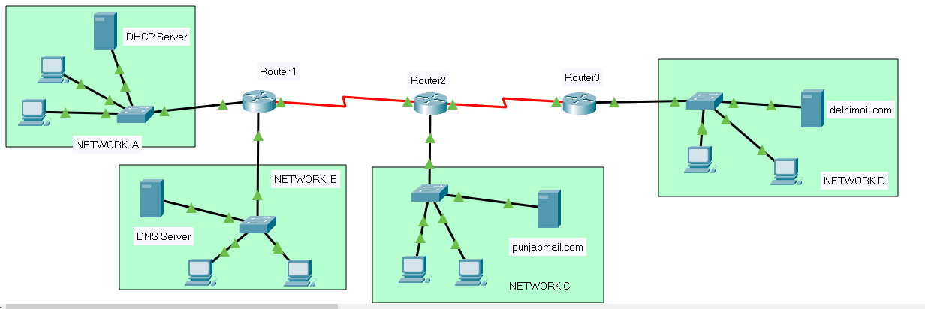
SET-A
Connect following three networks with following server in each network:
Network Server
A: 200.23.26.0 /24 DHCP Server
B: 191.220.0.0 /16 DNS Server
C: 207.45.65.0 /24 punjabmail server
D: 192.168.10.0/24 delhimail server

create at least two users for each email domain and demonstrate the e-mail communication between the users of different domains.

SET-B
Connect following three networks with following server in each network:
Network Server
A: 202.203.26.0 /24 DHCP Server
B: 191.219.0.0 /16 DNS Server
C: 107.45.65.0 /8 punjabmail server
D: 192.168.40.0/24 delhimail server

create at least two users for each email domain and demonstrate the e-mail communication between the users of different domains.

